2022 Season
Auction draft format.

RK = Rank at the end of the season
Team = Team Name (Team owner)
REC = Record at the end of the season
PF = Points For; number of points the team scored that year. How strong of a team they were offensively.
PA = Points Against; number of points scored against the team that year. How strong or weak their competition was that year.
PF/G = Points For per Game; average number of points scored per game by the team that year
PA/G = Points Against per Game; avg number of points scored against the team per game that year
DIFF = Average point differential that year. + means scored more than opponents, - means scored less than opponents.
MOVES = number of trades, waiver wire acquisitions, player drops or other roster moves.

Final Records & Stats

RK | Team | REC | PF | PA | PF/G | PA/G | DIFF
1 | Team Cross (Andy Cross) | 10-4-0 | 1652.1 | 1395.2 | 118.0 | 99.7 | +18.3
2 | Team REAPER (rey salinas) | 11-3-0 | 1698.7 | 1542.9 | 121.3 | 110.2 | +11.1
3 | Jiggle My Iggles (Joe Rasar) | 10-4-0 | 1562.3 | 1474.5 | 111.6 | 105.3 | +6.3
4 | Team Johnson (Robbie Johnson) | 7-7-0 | 1564.4 | 1534.9 | 111.7 | 109.6 | +2.1
5 | UNCLE RICO (Matt Lehman) | 8-6-0 | 1651.3 | 1462.5 | 118.0 | 104.5 | +13.5
6 | Nuclear Ultra MAGA Bruce (Bruce Lehman) | 7-7-0 | 1592.0 | 1590.3 | 113.7 | 113.6 | +0.1
7 | Sergeant Shultz (John Shultz) | 5-9-0 | 1506.9 | 1621.7 | 107.6 | 115.8 | -8.2
8 | Team Oliver (Daniel Oliver) | 5-9-0 | 1483.1 | 1631.0 | 105.9 | 116.5 | -10.6
9 | # Neverlast (Kevin Roth) | 5-9-0 | 1469.1 | 1611.2 | 104.9 | 115.1 | -10.1
10 | Team Hanstead (Garrett Hanstead) | 6-8-0 | 1475.6 | 1459.6 | 105.4 | 104.3 | +1.1
11 | Team Moe (jason moe) | 5-9-0 | 1429.8 | 1596.0 | 102.1 | 114.0 | -11.9
12 | Team Crandall (nick crandall) | 5-9-0 | 1466.6 | 1632.1 | 104.8 | 116.6 | -11.8

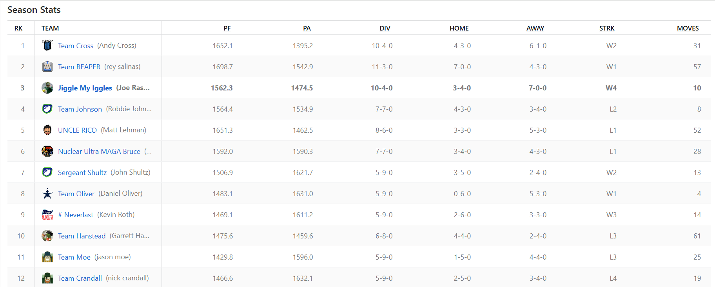

Season Stats
RK | Team
1 | Team Cross (Andy Cross)
2 | Team REAPER (rey salinas)
3 | Jiggle My Iggles (Joe Rasar)
4 | Team Johnson (Robbie Johnson)
5 | UNCLE RICO (Matt Lehman)
6 | Nuclear Ultra MAGA Bruce (Bruce Lehman)
7 | Sergeant Shultz (John Shultz)
8 | Team Oliver (Daniel Oliver)
9 | # Neverlast (Kevin Roth)
10 | Team Hanstead (Garrett Hanstead)
11 | Team Moe (jason moe)
12 | Team Crandall (nick crandall)

PF | PA | DIV | HOME | AWAY | STRK | MOVES
1652.1 | 1395.2 | 10-4-0 | 4-3-0 | 6-1-0 | W2 | 31
1698.7 | 1542.9 | 11-3-0 | 7-0-0 | 4-3-0 | W1 | 57
1562.3 | 1474.5 | 10-4-0 | 3-4-0 | 7-0-0 | W4 | 10
1564.4 | 1534.9 | 7-7-0 | 4-3-0 | 3-4-0 | L2 | 8
1651.3 | 1462.5 | 8-6-0 | 3-3-0 | 5-3-0 | L1 | 52
1592.0 | 1590.3 | 7-7-0 | 3-4-0 | 4-3-0 | L1 | 28
1506.9 | 1621.7 | 5-9-0 | 3-5-0 | 2-4-0 | W2 | 13
1483.1 | 1631.0 | 5-9-0 | 0-6-0 | 5-3-0 | W1 | 4
1469.1 | 1611.2 | 5-9-0 | 2-6-0 | 3-3-0 | W3 | 14
1475.6 | 1459.6 | 6-8-0 | 4-4-0 | 2-4-0 | L3 | 61
1429.8 | 1596.0 | 5-9-0 | 1-5-0 | 4-4-0 | L3 | 25
1466.6 | 1632.1 | 5-9-0 | 2-5-0 | 3-4-0 | L4 | 19

Final Week Scores

Winner's Bracket
- Team Cross
- (10-4-0, 1st)
- 123.1
- Team REAPER
- (11-3-0, 2nd)
- 119.1
Box Score
CHAMPIONSHIP MATCHUP

Winner's Consolation Ladder
- 
- Team Johnson
- (7-7-0, 4th)
- 82.0
- 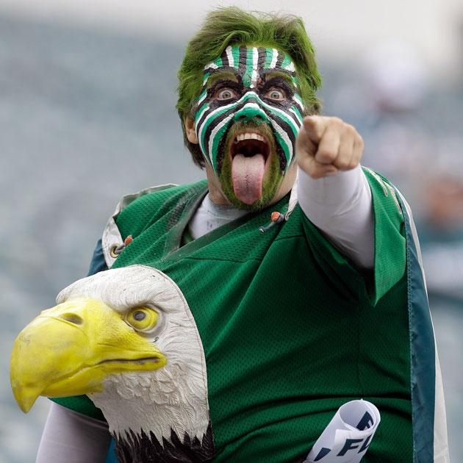
- Jiggle My Iggles
- (10-4-0, 3rd)
- 136.8
Box Score
- 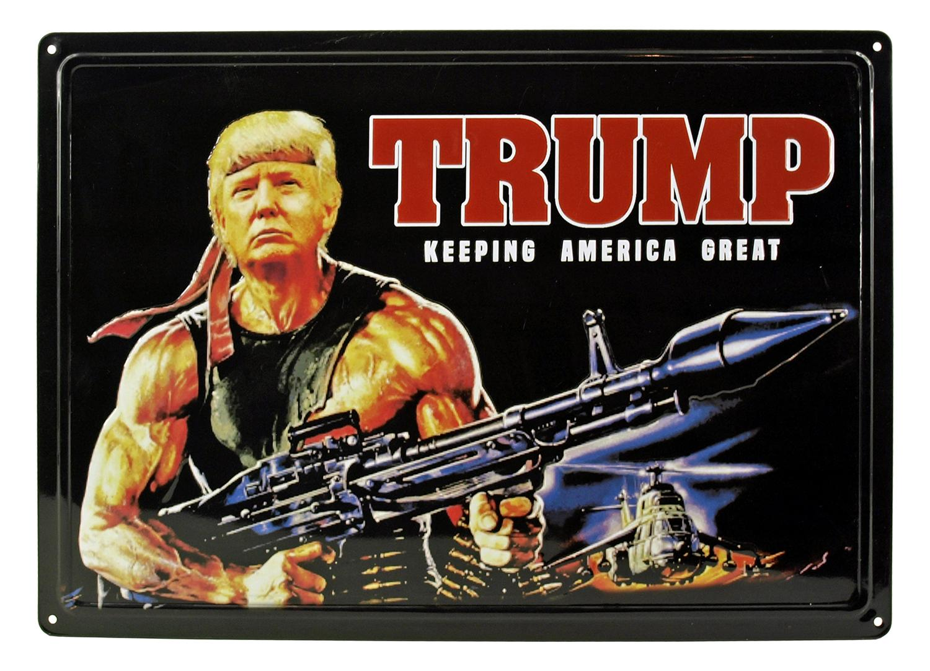
- Nuclear Ultra MAGA Bruce
- (7-7-0, 6th)
- 57.2
- UNCLE RICO
- (8-6-0, 5th)
- 197.5
Box Score

Consolation Ladder
- 
- Team Oliver
- (5-9-0, 8th)
- 102.1
- 
- Sergeant Shultz
- (5-9-0, 7th)
- 113.6
Box Score
- # Neverlast
- (5-9-0, 9th)
- 85.3
- 
- Team Hanstead
- (6-8-0, 10th)
- 83.4
Box Score
- Team Crandall
- (5-9-0, 12th)
- 52.9
- Team Moe
- (5-9-0, 11th)
- 60.1
Box Score

Draft Results: See the 2022 - DRAFT RESULTS spreadsheet
In an auction draft each team gets $200 to spend on their roster. They can spend as much or little on any player they want as long as they have the budget. Every roster spot must be filled and a player must cost at least $1 or more. Players are randomly selected to be put up for auction and then all teams commence on bidding until the highest amount wins the player for their team. Market conditions, budget, timing, player values, all play huge factors in how a draft can turn out.

Team Cross (Andy Cross)

STARTERS |  | Offseason |  |  | 2022 season
SLOT | Player | %ST | %ROST | +/- | PRK | FPTS | avg | LAST
QB |   Brock PurdyQ  SFQB | 24.2 | 40.8 | +4.9 | 33 | 108.7 | 12.1 | 19.7
RB | 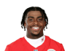  Jerick McKinnon  KCRB | 59.2 | 83.9 | +1.3 | 20 | 201.3 | 11.8 | 8.6
WR |   Davante Adams  LVWR | 97.4 | 99.9 | 0 | 3 | 360.5 | 21.2 | 12.3
TE |   George Kittle  SFTE | 92.1 | 99.3 | +0.1 | 3 | 205.5 | 13.7 | 18.9
FLEX | 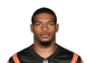  Ja'Marr Chase  CinWR | 94.4 | 99.9 | 0 | 11 | 254.4 | 21.2 | 22.6
FLEX |   Amon-Ra St. Brown  DetWR | 91.2 | 99.6 | +0.1 | 8 | 275.6 | 17.2 | 10.9
FLEX |   Jerry Jeudy  DenWR | 49.7 | 91.1 | 0 | 23 | 213.2 | 14.2 | 26.3
D/ST |   Giants  NYGD/ST | 23.2 | 33.0 | -1.1 | 20 | 114.0 | 6.7 | 6.0
 |  |  |  | TOTALS |  | 1733.2 | 118.17 | 125.3
Bench | 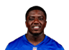  Devin Singletary  HouRB | 37.1 | 91.0 | -0.2 | 23 | 179.9 | 11.2 | 2.2
Bench |   David Njoku  CleTE | 42.5 | 83.8 | -0.4 | 12 | 142.0 | 10.1 | 14.2
Bench |   Mack Hollins  LVWR | 3.9 | 19.0 | -0.9 | 46 | 156.0 | 9.2 | 3.5
Bench |   Jaguars  JaxD/ST | 40.5 | 49.3 | +3.5 | 6 | 140.0 | 8.2 | 16.0
Bench |   Courtland Sutton  DenWR | 21.6 | 83.4 | +0.3 | 43 | 161.4 | 10.8 | 12.3
 |  |  |  | TOTALS |  | 779.3 | 49.56 | 48.2
IR |   Tua Tagovailoa  MiaQB | 21.1 | 82.7 | -4.9 | 13 | 258.2 | 19.9 | --

Team REAPER (rey salinas)

STARTERS |  | Offseason |  |  | 2022 season
SLOT | Player | %ST | %ROST | +/- | PRK | FPTS | avg | LAST
QB |   Gardner Minshew  IndQB | 19.1 | 36.0 | -3.6 | 45 | 41.5 | 8.3 | --
RB |   Tyler Allgeier  AtlRB | 41.3 | 69.9 | +8.5 | 29 | 163.4 | 10.2 | 15.5
WR | 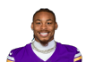  Justin Jefferson  MinWR | 96.9 | 99.9 | 0 | 1 | 390.5 | 23.0 | 7.8
TE |   Dallas Goedert  PhiTE | 49.8 | 90.7 | +0.5 | 10 | 143.2 | 11.9 | 10.6
FLEX | 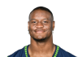  Kenneth Walker III  SeaRB | 61.1 | 96.8 | +0.2 | 16 | 218.5 | 14.6 | 15.4
FLEX |   Christian McCaffrey  SFRB | 98.3 | 99.9 | 0 | 2 | 366.2 | 21.5 | 16.9
FLEX | 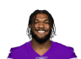  Cam Akers  LARRB | 64.0 | 90.1 | +4.2 | 34 | 147.3 | 9.8 | 17.8
D/ST |   Chiefs  KCD/ST | 56.6 | 71.5 | -3.7 | 11 | 129.0 | 7.6 | 12.0
 |  |  |  | TOTALS |  | 1599.6 | 106.93 | 96.0
Bench |   Jeff Wilson Jr.  MiaRB | 12.7 | 67.1 | -0.5 | 30 | 162.5 | 10.2 | 9.4
Bench | 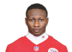  Marquise Brown  AriWR | 40.0 | 90.5 | +1.2 | 45 | 158.0 | 13.2 | 1.7
Bench | 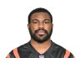  Zack Moss  IndRB | 18.3 | 45.4 | +1.2 | 63 | 66.5 | 5.1 | 23.1
Bench | 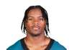  Jahan Dotson  WshWR | 11.2 | 44.5 | +2.7 | 50 | 132.6 | 10.2 | 10.2
Bench |   James Cook  BufRB | 9.1 | 47.7 | -0.2 | 45 | 105.7 | 6.6 | 7.1
 |  |  |  | TOTALS |  | 625.3 | 45.24 | 51.5
IR | 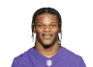  Lamar JacksonQ  BalQB | 19.4 | 92.7 | -2.9 | 14 | 249.8 | 19.2 | --

Jiggle My Iggles (Joe Rasar)

STARTERS |  | Offseason |  |  | 2022 season
SLOT | Player | %ST | %ROST | +/- | PRK | FPTS | avg | LAST
QB |   Daniel Jones  NYGQB | 26.1 | 64.1 | -2.6 | 9 | 299.8 | 18.7 | --
RB |   Dalvin CookQ  MinRB | 91.1 | 99.8 | -0.1 | 10 | 250.8 | 14.8 | 2.7
WR |   A.J. Brown  PhiWR | 95.7 | 99.8 | 0 | 5 | 313.6 | 18.4 | 13.5
TE |   Dawson Knox  BufTE | 41.9 | 77.7 | +0.7 | 15 | 135.7 | 9.0 | 9.3
FLEX |   Travis Etienne Jr.  JaxRB | 81.6 | 98.6 | +0.2 | 17 | 218.1 | 12.8 | 5.4
FLEX | 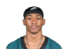  DeVonta Smith  PhiWR | 70.6 | 95.2 | +0.7 | 9 | 265.6 | 15.6 | 13.7
FLEX |   Rhamondre Stevenson  NERB | 69.3 | 98.0 | +0.1 | 9 | 253.1 | 14.9 | 13.2
D/ST |   Patriots  NED/ST | 43.3 | 73.8 | -2.7 | 1 | 194.0 | 11.4 | 11.0
 |  |  |  | TOTALS |  | 1930.7 | 115.74 | 68.8
Bench | 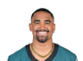  Jalen Hurts  PhiQB | 49.6 | 99.7 | 0 | 3 | 392.0 | 26.1 | 8.3
Bench |   Ezekiel Elliott  FARB | 76.3 | 96.8 | 0 | 22 | 185.8 | 12.4 | 1.0
Bench | 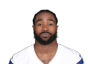  Miles Sanders  CarRB | 70.7 | 96.4 | +0.3 | 15 | 223.7 | 13.2 | 3.3
Bench |   Pat FreiermuthQ  PitTE | 59.4 | 92.8 | -0.5 | 9 | 148.2 | 9.3 | 0.0
Bench |   Falcons  AtlD/ST | 3.7 | 7.1 | +0.7 | 29 | 104.0 | 6.1 | 3.0
 |  |  |  | TOTALS |  | 1053.7 | 67.06 | 15.6
IR |   Empty | -- | -- | -- | -- | -- | -- | --

Team Johnson (Robbie Johnson)

STARTERS |  | Offseason |  |  | 2022 season
SLOT | Player | %ST | %ROST | +/- | PRK | FPTS | avg | LAST
QB |   Kirk Cousins  MinQB | 52.4 | 90.5 | +0.1 | 8 | 304.7 | 17.9 | 13.0
RB |   Nick Chubb  CleRB | 91.5 | 99.7 | 0 | 5 | 296.4 | 17.4 | 23.2
WR |   Jaylen Waddle  MiaWR | 83.5 | 99.7 | 0 | 7 | 278.2 | 16.4 | 10.3
TE |   Evan Engram  JaxTE | 64.8 | 85.1 | +2.3 | 5 | 180.9 | 10.6 | 6.7
FLEX |   Chris Godwin  TBWR | 67.9 | 96.6 | 0 | 19 | 226.8 | 15.1 | 9.5
FLEX |   Cordarrelle Patterson  AtlRB | 22.0 | 82.9 | 0 | 31 | 158.7 | 12.2 | 9.9
FLEX | 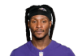  DeAndre HopkinsQ  AriWR | 33.6 | 94.4 | -4.4 | 47 | 155.7 | 17.3 | --
D/ST |   Vikings  MinD/ST | 18.5 | 27.0 | +5.7 | 9 | 131.0 | 7.7 | 7.0
 |  |  |  | TOTALS |  | 1732.4 | 114.7 | 79.6
Bench |   Aaron Rodgers  GBQB | 42.1 | 83.4 | +5.5 | 15 | 240.8 | 14.2 | 11.2
Bench |   Allen Lazard  NYJWR | 28.0 | 85.0 | +1.3 | 37 | 176.8 | 11.8 | 14.1
Bench |   Dalton Schultz  HouTE | 71.7 | 93.7 | +0.4 | 11 | 142.7 | 9.5 | 7.3
Bench |   Joshua Palmer  LACWR | 11.1 | 62.6 | -1.7 | 38 | 176.3 | 11.0 | 9.9
Bench |   Michael Carter  NYJRB | 15.5 | 73.6 | -0.9 | 40 | 126.0 | 7.9 | 2.5
 |  |  |  | TOTALS |  | 862.6 | 54.36 | 45.0
IR |   Cooper KuppQ  LARWR | 14.9 | 80.0 | -0.7 | 22 | 217.4 | 24.2 | --

UNCLE RICO (Matt Lehman)

STARTERS |  | Offseason |  |  | 2022 season
SLOT | Player | %ST | %ROST | +/- | PRK | FPTS | avg | LAST
QB |   Patrick MahomesQ  KCQB | 96.2 | 99.9 | 0 | 1 | 446.0 | 26.2 | 14.9
RB | 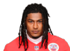  Isiah Pacheco  KCRB | 48.3 | 84.6 | 0 | 38 | 137.0 | 8.1 | 12.4
WR | 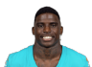  Tyreek Hill  MiaWR | 98.1 | 100.0 | 0 | 2 | 369.2 | 21.7 | 4.3
TE |   Mark Andrews  BalTE | 88.9 | 99.5 | 0 | 4 | 196.5 | 13.1 | --
FLEX |   Mike Evans  TBWR | 70.2 | 98.1 | +0.1 | 14 | 239.4 | 16.0 | --
FLEX |   Raheem Mostert  MiaRB | 23.9 | 79.1 | -0.3 | 26 | 172.3 | 10.8 | 8.1
FLEX |   Brandon Aiyuk  SFWR | 44.8 | 90.6 | +0.5 | 18 | 229.8 | 13.5 | 9.9
D/ST |   Titans  TenD/ST | 20.1 | 36.9 | -3 | 27 | 107.0 | 6.3 | 4.0
 |  |  |  | TOTALS |  | 1897.2 | 115.65 | 53.6
Bench |   Jamaal Williams  NORB | 36.8 | 86.9 | +0.8 | 12 | 232.9 | 13.7 | 19.2
Bench |   Ravens  BalD/ST | 68.4 | 86.4 | -5.3 | 8 | 133.0 | 7.8 | 5.0
Bench |   AJ Dillon  GBRB | 28.0 | 77.6 | +2.3 | 27 | 167.6 | 9.9 | 3.3
Bench |   DJ Chark  DetWR | 6.9 | 31.8 | +0.1 | 74 | 101.2 | 9.2 | 4.4
Bench |   Chris Moore  HouWR | 3.4 | 12.8 | -0.6 | 57 | 117.1 | 7.3 | 4.0
 |  |  |  | TOTALS |  | 751.8 | 47.9 | 35.9
IR |   Empty | -- | -- | -- | -- | -- | -- | --

Nuclear Ultra MAGA Bruce (Bruce Lehman)

STARTERS |  | Offseason |  |  | 2022 season
SLOT | Player | %ST | %ROST | +/- | PRK | FPTS | avg | LAST
QB |   Trevor Lawrence  JaxQB | 45.0 | 83.8 | +2 | 7 | 305.3 | 18.0 | 10.1
RB | 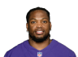  Derrick Henry  TenRB | 74.6 | 99.8 | +0.1 | 4 | 323.6 | 20.2 | 15.8
WR |   Stefon Diggs  BufWR | 98.0 | 100.0 | 0 | 4 | 335.6 | 21.0 | 26.4
TE |   Tyler Conklin  NYJTE | 17.7 | 37.4 | 0 | 16 | 131.5 | 7.7 | 3.3
FLEX | 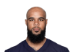  Keenan Allen  LACWR | 87.0 | 98.7 | +0.1 | 42 | 168.0 | 16.8 | 32.2
FLEX | 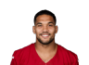  James ConnerQ  AriRB | 67.1 | 96.2 | -2.5 | 19 | 202.2 | 15.6 | --
FLEX |   Tony PollardQ  DalRB | 55.2 | 96.7 | +0.5 | 7 | 265.8 | 16.6 | 1.9
D/ST |   Seahawks  SeaD/ST | 14.8 | 24.9 | 0 | 7 | 134.0 | 7.9 | 8.0
 |  |  |  | TOTALS |  | 1866.0 | 123.74 | 97.7
Bench |   Jets  NYJD/ST | 29.3 | 51.0 | 0 | 25 | 109.0 | 6.4 | 1.0
Bench | 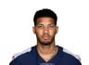  Tyler BoydQ  CinWR | 10.2 | 70.6 | -0.4 | 36 | 177.0 | 11.1 | 10.1
Bench |   Noah Fant  SeaTE | 14.3 | 40.2 | +0.1 | 17 | 122.6 | 7.2 | 6.0
Bench |   Michael GallupQ  DalWR | 12.6 | 54.7 | -0.5 | 68 | 105.4 | 7.5 | 2.0
Bench |   Empty | -- | -- | -- | -- | -- | -- | --
 |  |  |  | TOTALS |  | 514.0 | 32.21 | 19.1
IR |   Jakobi Meyers  LVWR | 12.5 | 71.7 | +0.8 | 29 | 183.3 | 13.1 | 12.2

Sergeant Shultz (John Shultz)

STARTERS |  | Offseason |  |  | 2022 season
SLOT | Player | %ST | %ROST | +/- | PRK | FPTS | avg | LAST
QB |   Tom Brady  TBQB | 45.2 | 85.7 | -0.2 | 12 | 288.7 | 17.0 | 7.2
RB |   Najee Harris  PitRB | 79.5 | 97.6 | +0.6 | 14 | 225.3 | 13.3 | 14.0
WR |   DK Metcalf  SeaWR | 87.6 | 99.1 | +0.1 | 16 | 233.8 | 13.8 | 7.0
TE |   Travis Kelce  KCTE | 99.1 | 100.0 | 0 | 1 | 328.3 | 19.3 | 9.8
FLEX |   J.K. Dobbins  BalRB | 28.6 | 79.4 | -1.3 | 55 | 85.2 | 10.7 | --
FLEX |   Michael Pittman Jr.  IndWR | 60.5 | 96.8 | 0 | 21 | 220.5 | 13.8 | 12.0
FLEX |   Terry McLaurin  WshWR | 67.8 | 98.1 | -0.1 | 15 | 238.0 | 14.0 | 16.4
D/ST |   Bills  BufD/ST | 70.1 | 94.1 | +1.1 | 5 | 145.0 | 9.1 | 22.0
 |  |  |  | TOTALS |  | 1764.8 | 110.79 | 88.4
Bench |   Gus Edwards  BalRB | 3.4 | 28.6 | -1.4 | 66 | 59.3 | 6.6 | 1.6
Bench | 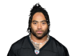  Jaylen Warren  PitRB | 0.9 | 8.2 | -0.2 | 48 | 93.3 | 5.8 | 7.3
Bench |   Marquez Valdes-Scantling  KCWR | 6.7 | 47.0 | -0.6 | 53 | 124.4 | 7.3 | 5.7
Bench | 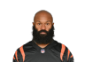  Samaje Perine  DenRB | 3.9 | 40.4 | -2 | 35 | 144.1 | 9.0 | 3.2
Bench |   Zonovan Knight  NYJRB | 26.2 | 65.3 | -2.8 | 67 | 59.0 | 7.4 | 2.2
 |  |  |  | TOTALS |  | 480.1 | 36.12 | 20.0
IR |   Darren Waller  NYGTE | 40.2 | 82.1 | +1.4 | 31 | 84.8 | 9.4 | 5.5

Team Oliver (Daniel Oliver)

STARTERS |  | Offseason |  |  | 2022 season
SLOT | Player | %ST | %ROST | +/- | PRK | FPTS | avg | LAST
QB |   Justin HerbertQ  LACQB | 73.8 | 97.8 | -0.4 | 11 | 292.9 | 17.2 | 18.7
RB |   Austin Ekeler  LACRB | 98.4 | 99.9 | 0 | 1 | 379.7 | 22.3 | 9.0
WR | 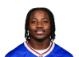  Curtis Samuel  WshWR | 8.1 | 58.6 | -0.8 | 34 | 177.3 | 10.4 | 0.4
TE |   Tyler Higbee  LARTE | 37.1 | 78.0 | +1.8 | 7 | 152.0 | 8.9 | 7.3
FLEX | 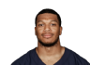  DJ Moore  ChiWR | 58.6 | 95.0 | +0.5 | 24 | 208.1 | 12.2 | 2.0
FLEX |   Tyler Lockett  SeaWR | 37.6 | 93.6 | +0.5 | 13 | 244.3 | 15.3 | 15.4
FLEX |   Diontae Johnson  PitWR | 43.3 | 89.5 | -0.1 | 30 | 180.7 | 10.6 | 7.8
D/ST |   Cowboys  DalD/ST | 85.3 | 97.1 | +0.8 | 2 | 175.0 | 10.3 | 6.0
 |  |  |  | TOTALS |  | 1810.0 | 107.37 | 66.6
Bench | 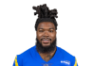  Darrell Henderson Jr.  FARB | 1.9 | 18.5 | -0.5 | 61 | 73.5 | 7.4 | --
Bench |   Geno Smith  SeaQB | 51.4 | 89.4 | +1.2 | 6 | 314.8 | 18.5 | 13.5
Bench |   Bengals  CinD/ST | 28.9 | 46.6 | +8.3 | 22 | 112.0 | 7.0 | 22.0
Bench |   Empty | -- | -- | -- | -- | -- | -- | --
Bench |   Empty | -- | -- | -- | -- | -- | -- | --
 |  |  |  | TOTALS |  | 500.3 | 32.87 | 35.5
IR |   Deebo Samuel  SFWR | 40.1 | 96.7 | -0.2 | 39 | 173.4 | 13.3 | 4.4

# Neverlast (Kevin Roth)

STARTERS |  | Offseason |  |  | 2022 season
SLOT | Player | %ST | %ROST | +/- | PRK | FPTS | avg | LAST
QB |   Dak Prescott  DalQB | 54.6 | 91.0 | +0.3 | 19 | 202.8 | 16.9 | 8.6
RB |   D'Onta Foreman  ChiRB | 24.4 | 77.3 | -1.2 | 37 | 141.0 | 8.3 | 6.8
WR |   Mike Williams  LACWR | 68.9 | 96.0 | +0.1 | 28 | 184.5 | 14.2 | 7.2
TE |   T.J. Hockenson  MinTE | 88.5 | 98.9 | -0.2 | 2 | 219.4 | 12.9 | 2.6
FLEX |   Saquon Barkley  NYGRB | 77.1 | 99.4 | -0.5 | 6 | 292.0 | 18.3 | --
FLEX | 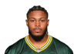  Josh Jacobs  LVRB | 90.5 | 99.7 | 0 | 3 | 345.3 | 20.3 | 7.0
FLEX |   Zay Jones  JaxWR | 42.9 | 78.0 | +0.7 | 26 | 205.1 | 12.8 | 6.1
D/ST |   49ers  SFD/ST | 88.8 | 97.1 | +0.8 | 4 | 152.0 | 8.9 | 15.0
 |  |  |  | TOTALS |  | 1742.1 | 112.61 | 53.3
Bench |   Adam Thielen  FAWR | 31.6 | 88.6 | -0.5 | 32 | 180.0 | 10.6 | 9.2
Bench | 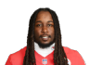  Kareem Hunt  CleRB | 13.3 | 70.3 | -1.1 | 39 | 126.8 | 7.5 | 5.8
Bench | 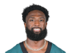  Parris Campbell  NYGWR | 3.3 | 32.9 | -1 | 48 | 149.1 | 8.8 | 12.8
Bench |   Brandin Cooks  DalWR | 20.4 | 73.9 | +0.2 | 49 | 147.6 | 11.4 | 23.6
Bench |   Darius Slayton  NYGWR | 12.5 | 44.0 | -2.4 | 52 | 131.4 | 8.2 | 0.0
 |  |  |  | TOTALS |  | 734.9 | 46.38 | 51.4
IR |   Empty | -- | -- | -- | -- | -- | -- | --

Team Hanstead (Garrett Hanstead)

STARTERS |  | Offseason |  |  | 2022 season
SLOT | Player | %ST | %ROST | +/- | PRK | FPTS | avg | LAST
QB |   Justin Fields  ChiQB | 41.4 | 89.3 | -7.9 | 5 | 316.7 | 21.1 | --
RB |   Aaron Jones  GBRB | 84.0 | 99.3 | +0.1 | 8 | 258.6 | 15.2 | 7.8
WR |   Tee Higgins  CinWR | 84.6 | 99.4 | 0 | 17 | 232.9 | 14.6 | 1.7
TE |   Chigoziem Okonkwo  TenTE | 4.7 | 12.2 | -0.6 | 25 | 97.2 | 5.7 | 13.2
FLEX |   D'Andre Swift  DetRB | 70.5 | 97.4 | 0 | 21 | 193.1 | 13.8 | 15.6
FLEX | 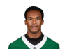  Garrett Wilson  NYJWR | 56.3 | 92.8 | +0.1 | 20 | 224.7 | 13.2 | 17.9
FLEX |   Alvin Kamara  NORB | 82.5 | 99.5 | 0 | 18 | 215.7 | 14.4 | 14.0
D/ST |   Raiders  LVD/ST | 15.0 | 23.5 | -2 | 32 | 88.0 | 5.2 | 2.0
 |  |  |  | TOTALS |  | 1626.9 | 103.17 | 72.2
Bench |   Chris Olave  NOWR | 22.3 | 90.9 | +0.1 | 25 | 207.2 | 13.8 | 15.0
Bench | 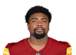  Treylon Burks  TenWR | 2.5 | 40.8 | -0.3 | 78 | 96.1 | 8.7 | 5.9
Bench |   Deshaun Watson  CleQB | 22.2 | 63.8 | +0.5 | 36 | 86.3 | 14.4 | 17.6
Bench | 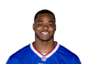  Amari Cooper  CleWR | 64.3 | 96.6 | +0.3 | 10 | 257.0 | 15.1 | 7.1
Bench |   Jared Goff  DetQB | 44.7 | 71.2 | +4.5 | 10 | 298.4 | 17.6 | 9.3
 |  |  |  | TOTALS |  | 945.0 | 69.6 | 54.9
IR |   Mike Boone  HouRB | 0.7 | 5.0 | -0.2 | 93 | 28.8 | 3.2 | --

Team Moe (jason moe)

STARTERS |  | Offseason |  |  | 2022 season
SLOT | Player | %ST | %ROST | +/- | PRK | FPTS | avg | LAST
QB |   Joe Burrow  CinQB | 81.1 | 99.3 | +0.2 | 4 | 376.9 | 23.6 | 11.6
RB |   Brian Robinson Jr.Q  WshRB | 27.1 | 74.4 | -3.2 | 43 | 114.7 | 9.6 | --
WR |   CeeDee Lamb  DalWR | 96.2 | 99.8 | 0 | 6 | 311.6 | 18.3 | 16.2
TE |   Gerald Everett  LACTE | 33.7 | 76.2 | -1.7 | 13 | 139.5 | 8.7 | 9.8
FLEX |   Joe Mixon  CinRB | 93.9 | 99.8 | 0 | 11 | 241.5 | 17.3 | 17.8
FLEX | 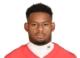  JuJu Smith-Schuster  NEWR | 48.1 | 93.2 | +0.1 | 27 | 191.3 | 12.0 | 5.5
FLEX | 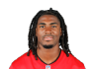  Rachaad White  TBRB | 17.4 | 64.3 | -1.5 | 36 | 141.1 | 8.3 | 1.5
D/ST |   Steelers  PitD/ST | 34.3 | 44.1 | +0.4 | 16 | 121.0 | 7.1 | 13.0
 |  |  |  | TOTALS |  | 1637.6 | 104.79 | 75.4
Bench | 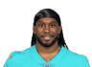  Alexander Mattison  MinRB | 1.0 | 20.2 | -0.2 | 52 | 88.4 | 5.2 | 19.0
Bench |   George Pickens  PitWR | 12.9 | 61.3 | -0.6 | 41 | 168.5 | 9.9 | 16.2
Bench | 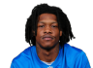  Jameson Williams  DetWR | 1.0 | 21.0 | -0.6 | 155 | 16.1 | 2.7 | 0.0
Bench |   Donovan Peoples-Jones  CleWR | 12.1 | 46.2 | -1.4 | 40 | 169.1 | 9.9 | 6.2
Bench |   Foster Moreau  LVTE | 6.7 | 19.3 | -0.9 | 30 | 85.2 | 5.7 | 2.0
 |  |  |  | TOTALS |  | 527.3 | 33.42 | 43.4
IR | 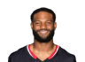  Nico CollinsQ  HouWR | 0.9 | 14.4 | -0.9 | 77 | 97.1 | 9.7 | --

Team Crandall (nick crandall)

STARTERS |  | Offseason |  |  | 2022 season
SLOT | Player | %ST | %ROST | +/- | PRK | FPTS | avg | LAST
QB |   Josh Allen  BufQB | 95.4 | 100.0 | 0 | 2 | 422.0 | 26.4 | 23.6
RB |   Latavius Murray  DenRB | 36.6 | 77.2 | +0.1 | 32 | 158.2 | 12.2 | 20.8
WR |   Christian Watson  GBWR | 49.4 | 89.4 | +0.8 | 35 | 177.1 | 12.7 | 18.6
TE |   Juwan Johnson  NOTE | 7.3 | 22.2 | -0.6 | 14 | 135.8 | 8.5 | 3.1
FLEX |   Leonard Fournette  FARB | 61.8 | 96.9 | -0.5 | 13 | 228.1 | 14.3 | 1.4
FLEX | 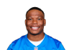  David Montgomery  DetRB | 65.0 | 95.7 | 0 | 24 | 179.7 | 11.2 | 2.1
FLEX | 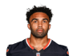  Christian KirkQ  JaxWR | 62.8 | 95.3 | +0.3 | 12 | 247.9 | 14.6 | 21.9
D/ST |   Eagles  PhiD/ST | 79.0 | 94.4 | +1.2 | 3 | 163.0 | 9.6 | 2.0
 |  |  |  | TOTALS |  | 1711.8 | 109.34 | 93.5
Bench |   Drake London  AtlWR | 17.2 | 75.8 | +1 | 31 | 180.6 | 10.6 | 20.0
Bench |   Gabe Davis  BufWR | 41.0 | 92.9 | 0 | 33 | 179.6 | 12.0 | 6.9
Bench |   Hayden Hurst  CarTE | 7.2 | 38.6 | -0.2 | 21 | 105.4 | 8.1 | 5.4
Bench |   Van Jefferson  LARWR | 3.1 | 20.9 | -0.9 | 93 | 78.9 | 7.2 | 9.1
Bench |   Daniel Bellinger  NYGTE | 4.1 | 10.0 | -0.5 | 34 | 75.0 | 6.3 | --
 |  |  |  | TOTALS |  | 619.5 | 44.13 | 41.4
IR |   Empty | -- | -- | -- | -- | -- | -- | --

